

|  |  |  |  |  |  |  |  |  |
| --- | --- | --- | --- | --- | --- | --- | --- | --- |
|  | | | | | | | | |
|  | | Human Development index and its state wise comparative Analysis: Odisha and West Bengal. | | | | |  | |
|  |  | | | | | | |  |
|  | | | |  |  | | | |
|  | | | | Anumoy Modak (ME22002) |  | | | |
|  | | | | **Date**Monday, November 6, 2023**Course title**Development Economics**Project Guide:** **Dr. Biswaranjan Parida** |  | | | |
|  | | |  | | |  | | |



|  |  |  |  |  |  |  |  |  |
| --- | --- | --- | --- | --- | --- | --- | --- | --- |
|  |  | | |  |  | | |  |
|  | Contents | | | | | | |  |
|  |  | | |  |  | | |  |
|  |  | |  | | |  | |  |
|  |  |  | * Introduction: HDI  1. Concept 2. Formulation and Methodology  * SHDI: West Bengal. * SHDI: Odisha. * The Comparative Analysis: The Conclusion. * Reference. | | |  |  |  |
|  | | | | |
|  |  |  |  |
|  |  |



|  |  |  |  |  |  |  |
| --- | --- | --- | --- | --- | --- | --- |
|  | |  |  |  |  | |
|  | | Introduction: HDI | | |  | |
|  | |  |  |  |  | |
|  | Concept: HDI stands for Human Development Index. It is a summary measure of human development in a country, introduced by the United Nations Development Program (UNDP) in 1990. The HDI is calculated based on three key dimensions:  1. **Health:** Measured by life expectancy at birth.  2.**Education:** Measured by mean years of schooling and expected years of schooling.  3. **Standard of living:** Measured by gross national income (GNI) per capita, adjusted for purchasing power parity.  The HDI is designed to provide a comprehensive view of a country's overall development by considering not only economic factors but also health and education indicators. Countries with higher HDI values are generally considered to have a higher standard of living and a better quality of life for their citizens. The scale ranges from 0 to 1, with 1 representing the highest level of human development.  It was conceived by Abdul Latif poverty Action Lab. Formulation and Methodology: The Human Development Index (HDI) is calculated using a specific formula that takes into account three basic dimensions of human development: health, education, and standard of living. Here's a breakdown of the formulation and methodology of HDI:  1. **Health Dimension: Life Expectancy at Birth**  - This component is measured by life expectancy at birth, which is an indicator of the overall health and longevity of a population.  - The life expectancy at birth is normalized on a scale from 0 to 1.  2. **Education Dimension**: Mean Years of Schooling and Expected Years of Schooling  - **Mean Years of Schooling (MYS**): This is the average number of years of education received by people aged 25 and older, based on educational attainment levels.  - **Expected Years of Schooling (EYS):** This is an estimate of the total number of years of schooling a child entering school at age 5 can expect to receive, assuming age-specific enrollment ratios remain the same throughout the child's life.  - Both MYS and EYS are normalized on a scale from 0 to 1.  3**. Standard of Living Dimension:** Gross National Income (GNI) per Capita  - GNI per capita is used as a measure of the standard of living in a country. It is adjusted for purchasing power parity (PPP) to account for differences in the cost of living and inflation rates between countries.  - GNI per capita is normalized on a scale from 0 to 1.  4. **Calculation of HDI:**  - The HDI is calculated as the geometric mean of the normalized indices for each of the three dimensions (life expectancy, mean years of schooling, and GNI per capita).  - The formula for HDI is: HDI = (Life Expectancy Index * Education Index * GNI Index) ^ (1/3)  **HDI = (I health x I education x I Income) ^1/3**  5. **Normalization:**  - Each of the three component indices (life expectancy, education, and GNI per capita) is scaled between 0 and 1 using a specific formula, ensuring that all three dimensions contribute equally to the overall HDI.  The HDI provides a comprehensive assessment of a country's development status by considering health, education, and standard of living indicators. It is widely used to compare and rank countries based on their level of human development.  Here is the Normalization method:   * **Index= Actual value- Minimum Value**   **Maximum value- minimum value** | | | | |  |

### **SHDI: West Bengal.**

The HDI index of west Bengal is consistently higher than the Indian HDI until 2004 at a decreasing rate of differences. In 2005 the Indian and the West Bengal HDI were equal at **0.534** normalized value. From 2006 onwards, while the West Bengal HDI has seen growth, its still lags behind the Indian HDI. Here, are the following illustrative data table and graphs:

|  |  |  |
| --- | --- | --- |
| **Years** | **India (HDI)** | **West Bengal (SHDI)** |
| 1991 | **0.437** | 0.446 |
| 1992 | **0.442** | 0.451 |
| 1993 | **0.446** | 0.456 |
| 1994 | **0.452** | 0.462 |
| 1995 | **0.458** | 0.468 |
| 1996 | **0.466** | 0.476 |
| 1997 | **0.471** | 0.481 |
| 1998 | **0.478** | 0.488 |
| 1999 | **0.486** | 0.496 |
| 2000 | **0.491** | 0.5 |
| 2001 | **0.496** | 0.503 |
| 2002 | **0.503** | 0.508 |
| 2003 | **0.516** | 0.519 |
| 2004 | **0.525** | 0.527 |
| 2005 | 0.534 | 0.534 |
| 2006 | **0.543** | 0.542 |
| 2007 | **0.553** | 0.549 |
| 2008 | **0.56** | 0.555 |
| 2009 | **0.565** | 0.558 |
| 2010 | **0.575** | 0.567 |
| 2011 | **0.588** | 0.578 |
| 2012 | **0.598** | 0.586 |
| 2013 | **0.607** | 0.596 |
| 2014 | **0.619** | 0.61 |
| 2015 | **0.629** | 0.622 |
| 2016 | **0.639** | 0.634 |
| 2017 | **0.644** | 0.637 |
| 2018 | **0.645** | 0.637 |
| 2019 | **0.645** | 0.636 |
| 2020 | **0.642** | 0.633 |
| 2021 | **0.633** | 0.624 |

Table :Indian and West Bengal HDI data_30years

Graph : comparative Analysis of Indian and WB HDI, line trend for 30 years

Graph : SHDI of WB for 30 years of data

#### SHDI: Odisha

The HDI index of Odisha is consistently lower than the Indian HDI. Odisha HDI maintains a consistent difference from Indian HDI and it always lags behind the Indian HDI measure. Thus, Odisha has consistently lower human development outcomes compared to rest of India. Here, are the following illustrative data table and graphs:

|  |  |  |
| --- | --- | --- |
| **Years** | India (HDI) | Odisha (SHDI) |
| 1991 | 0.437 | 0.405 |
| 1992 | 0.442 | 0.409 |
| 1993 | 0.446 | 0.413 |
| 1994 | 0.452 | 0.418 |
| 1995 | 0.458 | 0.424 |
| 1996 | 0.466 | 0.43 |
| 1997 | 0.471 | 0.435 |
| 1998 | 0.478 | 0.441 |
| 1999 | 0.486 | 0.448 |
| 2000 | 0.491 | 0.452 |
| 2001 | 0.496 | 0.456 |
| 2002 | 0.503 | 0.462 |
| 2003 | 0.516 | 0.473 |
| 2004 | 0.525 | 0.481 |
| 2005 | 0.534 | 0.489 |
| 2006 | 0.543 | 0.497 |
| 2007 | 0.553 | 0.507 |
| 2008 | 0.56 | 0.514 |
| 2009 | 0.565 | 0.519 |
| 2010 | 0.575 | 0.529 |
| 2011 | 0.588 | 0.542 |
| 2012 | 0.598 | 0.552 |
| 2013 | 0.607 | 0.562 |
| 2014 | 0.619 | 0.575 |
| 2015 | 0.629 | 0.586 |
| 2016 | 0.639 | 0.598 |
| 2017 | 0.644 | 0.604 |
| 2018 | 0.645 | 0.607 |
| 2019 | 0.645 | 0.608 |
| 2020 | 0.642 | 0.605 |
| 2021 | 0.633 | 0.597 |

Table : India and Odisha HDI data for 30 years.

Graph :comparative Analysis of Indian and Odisha HDI, line trend for 30 years

Graph :SHDI of ODA for 30 years of data

### **The Comparative Analysis: India, West Bengal and Odisha.( The Conclusion)**

**Part A: Comparison between West Bengal and Odisha SHDI (State Human Development Index):**

Graph : comparison between WB and ODA SHDI

From the above figure, we can see that Odisha is consistently lagging behind the West Bengal SHDI.

Graph : correlation HDI

However, the correlation between Odisha and West Bengal is higher than the correlation between Odisha and India in terms of HDI. This implies that the direction of the movement of ODA SHDI is closer to WB SHDI rather than Indian HDI, suggesting the existence of a relationship between ODA and WB SHDIs.

**Part B:** **Comparison between India, West Bengal and Odisha HDI (Human Development Index):**

Graph : Comparative Human Development Index (HDI) Analysis: State (Sub-nationals)

From the above graph 7, we can see a consistent improvement in Human Development outcomes of India, the tabular representation with respect to the graph is given below:

|  |  |  |  |
| --- | --- | --- | --- |
| **Years** | **Odisha (SHDI)** | **West Bengal (SHDI)** | **India (HDI)** |
| 1991 | 0.405 | 0.446 | **0.437** |
| 1992 | 0.409 | 0.451 | **0.442** |
| 1993 | 0.413 | 0.456 | **0.446** |
| 1994 | 0.418 | 0.462 | **0.452** |
| 1995 | 0.424 | 0.468 | **0.458** |
| 1996 | 0.43 | 0.476 | **0.466** |
| 1997 | 0.435 | 0.481 | **0.471** |
| 1998 | 0.441 | 0.488 | **0.478** |
| 1999 | 0.448 | 0.496 | **0.486** |
| 2000 | 0.452 | 0.5 | **0.491** |
| 2001 | 0.456 | 0.503 | **0.496** |
| 2002 | 0.462 | 0.508 | **0.503** |
| 2003 | 0.473 | 0.519 | **0.516** |
| 2004 | 0.481 | 0.527 | **0.525** |
| 2005 | 0.489 | 0.534 | **0.534** |
| 2006 | 0.497 | 0.542 | **0.543** |
| 2007 | 0.507 | 0.549 | **0.553** |
| 2008 | 0.514 | 0.555 | **0.56** |
| 2009 | 0.519 | 0.558 | **0.565** |
| 2010 | 0.529 | 0.567 | **0.575** |
| 2011 | 0.542 | 0.578 | **0.588** |
| 2012 | 0.552 | 0.586 | **0.598** |
| 2013 | 0.562 | 0.596 | **0.607** |
| 2014 | 0.575 | 0.61 | **0.619** |
| 2015 | 0.586 | 0.622 | **0.629** |
| 2016 | 0.598 | 0.634 | **0.639** |
| 2017 | 0.604 | 0.637 | **0.644** |
| 2018 | 0.607 | 0.637 | **0.645** |
| 2019 | 0.608 | 0.636 | **0.645** |
| 2020 | 0.605 | 0.633 | **0.642** |
| 2021 | 0.597 | 0.624 | **0.633** |

Table : Comparative HDI: India, West Bengal and Odisha, 30 years data

**Part c: Overall State-level Comparison, between 1991 and 2021.**

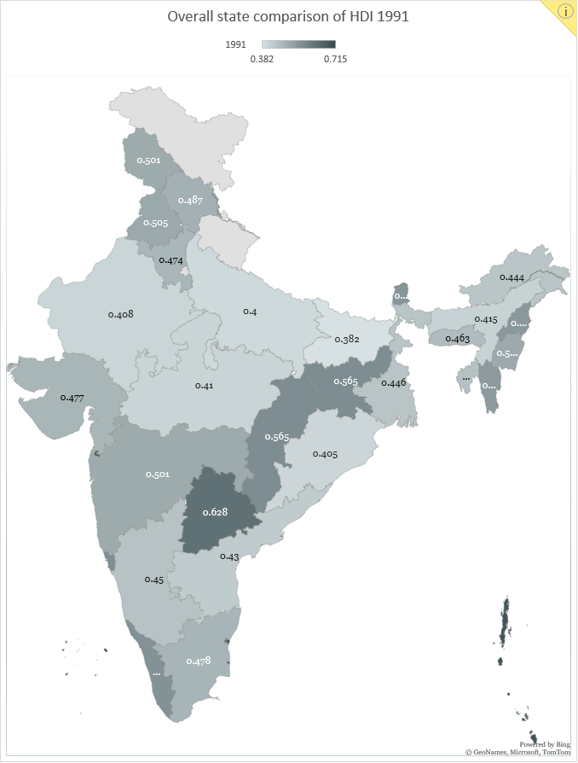

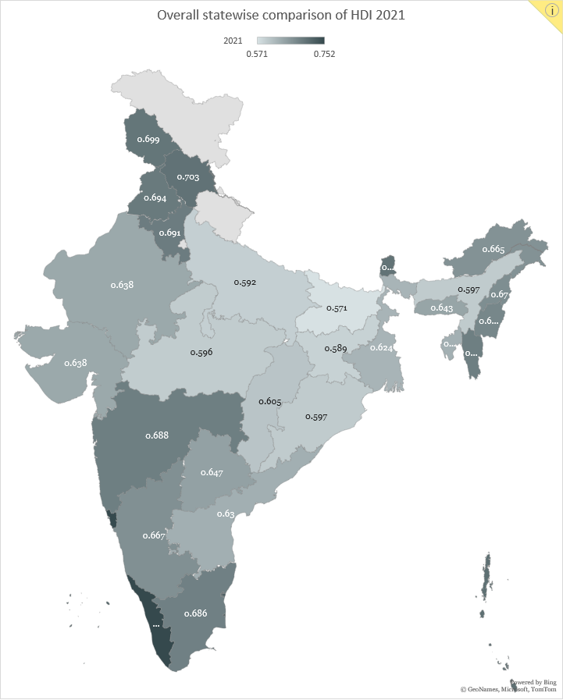

### Reference:

* **Global data lab :** [**https://globaldatalab.org/shdi/download/shdi/IND/?levels=1+4&interpolation=0&extrapolation=0**](https://globaldatalab.org/shdi/download/shdi/IND/?levels=1+4&interpolation=0&extrapolation=0)



* **UNDP, HDI Report:** [**https://hdr.undp.org/content/human-development-report-2021-22**](https://hdr.undp.org/content/human-development-report-2021-22)